

**ASSIGNMENT 1**

**INDIVIDUAL ASSIGNMENT**

**STAKEHOLDER MANAGEMENT IN HOSPITAL**

**Subject:** EPM5730 Project stakeholder Management

**Submitted by:** Surbhi Dhawan

**Student Id:** 4608520

**Submitted to :** Dr. Kim Claire

# **1.0 Introduction**

Stakeholder management is very important part of the project management to deliver a successful project for any company or product. It is a complete process of managing stakeholders in a system. It involves identification of stakeholders, listing them, categorising and prioritising them and take measure for their involvement in the project.

**Who are stakeholders?**

Stakeholders are the people, group or single human or may be a large organisation that are directly or indirectly involved in the project. These people can have major impact on the success of a project.

For example: considering a school education system where many people are involved in system

Like:

* School board members
* Administrators
* Teachers
* Students
* Parents
* Government officials
* State representative’s
* Community includes local schools, business owners and community leaders.





These all listed stakeholders have different impact on the school. Some have high impact or direct impact and some have low impact but all are directly or indirectly involved in the education system.

This assignment involves case study report on stakeholder issues facing project manager in hospital. The first section includes the explanation of shareholder and stakeholder theory. Next section will cover introduction to hospital system, present stakeholders, prioritisation of stakeholders, and issues faced by project managers in dealing with them.

# **2.0 Shareholder and Stakeholder theory**

Before understanding stakeholder analysis, we need to know about shareholder and stakeholder theory.

* Shareholders are people, company or organisation that have a share in a company and looking for profit of a company.
* Shareholder theory says that shareholders (Friedman, M., 2007) are the important and primary and company should work for their profit only.
* Stake holder theory says that shareholders are small part of stakeholders and there are many other people who have direct or indirect impact because of success or failure of project.
* It’s the duty of managers to balance both share holders and other people and don’t harm the surrounding (Donaldson, T. and Preston, L.E., 1995)

# **3.0 Types of stakeholders**

There are many stakeholders that have direct or indirect impact on the project. Some are very important, and some have very low impacts.

There are 3 types of stakeholders:

* **Internal Stakeholders:** these are those who work or are present in the organisation.
* **Interface Stakeholders:** those who are involved internally and externally
* **External Stakeholders:** stakeholders who are outside the organisation but impact the project.

The examples for these stakeholders are given under hospital system in topic 5.0

# **4.0 Stakeholder Management Plan**

Stakeholder management is a technique or procedure to identify all the stakeholders that have direct or indirect impact on the project and to observe stakeholder’s expectation on the project and strategies to manage stakeholder’s involvement throughout the project.

The stakeholder Management set up helps make sure that stakeholders are effectively concerned in project selections and execution (PMBOK fifth Edition) throughout the lifecycle of the project, to realize support for the project and anticipate resistance, conflict, or competitive objectives among the project’s stakeholders. The stakeholder Management set up includes many sections:

* **determine Stakeholders** – identify them by name and company, groups, and organizations that have major influence on project direction and its success or
* **set up stakeholder Management** – determine the ways and mechanisms which will be accustomed succeed the best support of stakeholders and minimize resistance.
* **Manage stakeholder Engagement** – outlines the processes and steps which will be undertaken to hold out the planned ways.
* **Control stakeholder Engagement** – describes the strategies which will be accustomed monitor stakeholder engagement and alert the project team if issues are created

# **5.0 Stakeholder Management in Hospital**

Hospitals are large organisation which affects to the entire society. In hospitals, stakeholder management has been very important to achieve specific objectives and goals in the society.

* **Internal Stakeholders:** Hospital staff, Doctors, nurses.
* **External Stakeholders:** patients, suppliers, competitors
* **Interface Stakeholders:** Trustees, Staff members, etc.

1. **Step 1: Identify Stakeholders**

The stakeholders present and involved in hospital are listed below:

|  |  |  |
| --- | --- | --- |
| S.NO. | KEY STAKEHOLDERS | TYPE OF STAKEHOLDERS |
| 1 | Doctors  and surgeons | Internal |
| 2 | Assistants  and receptionists | Internal |
| 3 | Nurses | Internal |
| 4 | Medical Students | Interface |
| 5 | Visitors | external |
| 6 | Patients | external |
| 7 | suppliers | external |
| 8 | Board of Directors | internals |
| 9 | community | external |
| 10 | Other hospitals | external |
| 11 | Funders | interface |
| 12 | State Government | External |
| 13 | Media | External |

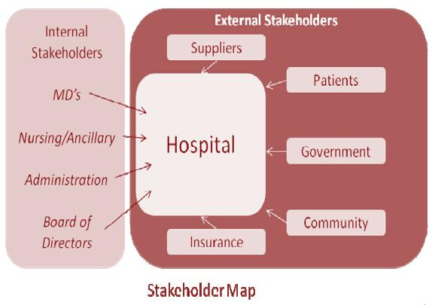

* The above is the list of possible stakeholders. Every stakeholder has been specified with the type.
* Doctors and surgeons, assistants, nurses, staff, board of directors’ work from with the organisation.
* Visitors, patients, suppliers, community are external stakeholders whereas medical students are the interface stakeholders that can work within or outside the organisation.

1. **Step 2: Prioritising Stakeholders**

The following grid shows the impact of stakeholders on working hospitals:

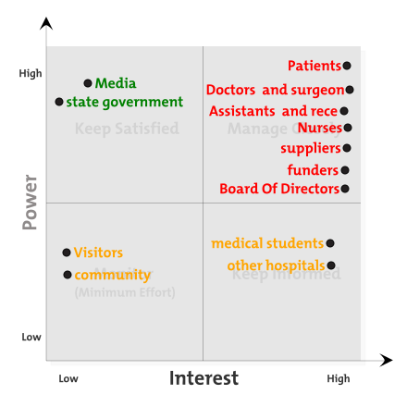

**I have divided the stakeholders in 4 groups and assigned general rating according to effect. I have not assigned numbers but just shown in 4 quadrants to depict their effect**

* **High Power/Low Interest:** media and state government who have high power in society but low interest in how the hospital is working. They can upgrade or degrade image of hospital.
* **High Power/High Interest:** Patients, Doctors, assistants, Board of directors, suppliers, funders all have high influence on hospital and are primary and most important stakeholders that have high impact on the organisation and shown red in colour
* **Low Power/Low Interest:** Visitors and community have low power and low interest in the hospital.
* **Low Power/High Interest:** medical students who have low power but are mostly interested in what practices are going in hospitals and other hospitals who act as competitors have high interest in work of organisation.

|  |  |  |  |
| --- | --- | --- | --- |
| S.no | Stakeholder | Interest | Impact |
| 1 | Doctors  and surgeons | Work for hospital | high |
| 2 | Assistants  and receptionists | Work for hospital | High |
| 3 | Nurses | Work for hospital | high |
| 4 | Medical Students | Apply for internship and practises | High/low |
| 5 | Visitors | Regular check-ups | Low/low |
| 6 | Patients | Original builders of hospital | high |
| 7 | suppliers | Supply goods machines, medicines and other equipment’s | High |
| 8 | Board of Directors | Manage whole hospital | high |
| 9 | community | Regular checkups | Low/low |
| 10 | Other hospitals | competitors | High/low |
| 11 | Funders | Give funds to company | high |
| 12 | State Government | Approves the business | Low/high |
| 13 | Media | Image builder | Low/high |

# **6.0 Stakeholders Problems /Issues in the system**

As stakeholders are the influents in a project and in hospital systems stakeholders play a very important role in managing a huge range of stakeholders. Several problems are faced by managers to deal with the stakeholders. Some of the problems are:

1. **When stakeholders want to work according to their needs, they follow up four strategies usage, withhold, direct and indirect.**

* Withhold strategies are those when any stakeholder. For example supplier in hospital is unsatisfied of certain things so supplier can withhold its resources i.e. discontinuation of resources which effects not only to the hospital but patients as well.
* Usage strategies are those when any stakeholder provide resources but with constraints or limitations.
* Direct strategies when stakeholders directly act on the system like going on strikes, boycott
* Indirect strategies when stakeholders perform act through third parties.

1. **If a stakeholder backs out due to no profits from hospital or no proper attention to him it can lead to debt.** For example: if Funder is not happy with profits or behaviour of organisation it can withdraw its shares from it.
2. **If a patient is not happy with the treatment it can badly affect the reputation of hospital.**

Therefore, stakeholder engagement is very important throughout the project.

# **7.0 Engagement of Stakeholders**

This can resolve all the problems faced by the hospital. If stakeholders are managed properly and their engagement is respected throughout. Few ways to engage them are:

* **Creating Forums:** this can help all government, experts, consumers and stakeholders to come together and can have conversation about future works
* **Regular consultations:** regular consultations like weekly and monthly are important so that every stakeholders’ demands are up to mark and easily understood.
* **Reviews:** if other stakeholders like external stakeholder such as patients need to be involved. Feedbacks and surveys can be taken tie to time to involve them.
* **Regular Meetings:** weekly or monthly meetings can be arranged in order to listen to point of view of every stakeholder that are important.
* **Stakeholder feedback:** feedback from stakeholders can help in number of ways (Curran, C.R. and Totten, M.K., 2010):

*To identify opportunity to understand needs of stakeholder.*

*Observing and managing threats and risks.*

*Observing influential areas of disagreement with stakeholder and solutions for it.*

*Sharing feedbacks with boards and policy makers.*

# **8.0 Conclusion**

* In this case study we came to know that stakeholders are very important part of any project and shareholders are mere part of every project.
* Share holder and stakeholder both are equally important in every project (Hillman, A.J. and Keim, G.D., 2001).
* All the case study followed qualitative method in which website articles, journals, and research papers were read.
* Hospital system is chosen, and all the stakeholders are clearly studied and prioritised.
* Stakeholders are prioritised in 4 quadrants.
* To run a successful project business ethics is must in which it says stakeholders should be kept happy.

# **9.0 References**

Friedman, M., 2007. The social responsibility of business is to increase its profits. In *Corporate ethics and corporate governance* (pp. 173-178). Springer, Berlin, Heidelberg.

Freeman, R.E. and Reed, D.L., 1983. Stockholders and stakeholders: A new perspective on corporate governance. *California management review*, *25*(3), pp.88-106.

*mindtool.com.* [ONLINE] Available https://www.mindtools.com/pages/article/newPPM_07.htm. [Last Accessed 21 August 2019].

*Stakeholdermap.com* [ONLINE] Available at: https://www.stakeholdermap.com/stakeholders-in-hospitals.html. [Last Accessed 21 August2019].

Donaldson, T. and Preston, L.E., 1995. The stakeholder theory of the corporation: Concepts, evidence, and implications. *Academy of management Review*, *20*(1), pp.65-91.

Hillman, A.J. and Keim, G.D., 2001. Shareholder value, stakeholder management, and social issues: what's the bottom line? *Strategic management journal*, *22*(2), pp.125-139.

Curran, C.R. and Totten, M.K., 2010. Mission, strategy, and stakeholders. *Nursing Economics*, *28*(2), p.116.